# Developer Workstation Setup

Table of Contents

Developer Workstation Setup 1

Download Maven 2

Download Eclipse for Java Developers 2

Import CQ Cookbook Project 3

FileVault Installation 4

Valutclipse plugin 5

Install web Development Tools 6

## Download Maven

<http://maven.apache.org/download.cgi>

**Mac Users**: Maven is already installed and you don’t need to download or install Maven.

Open a terminal window and cd to the CQ cookbook directory and run ‘mvn clean install’. This will build the entire project and download dependencies.

**Windows Users**: Install maven and add Maven to your class path so you can run the mvn command anywhere.

Download and extract the zip project to a directory.

Add MAVEN_HOME environment variable and add Maven bin to your PATH environment

Open a command window and cd to the CQ cookbook directory and run ‘mvn clean install’. This will build the entire project and download dependencies.

## Download Eclipse for Java Developers

<http://www.eclipse.org/downloads/packages/eclipse-ide-java-developers/keplersr1>

Eclipse is a compressed application. To install extract the zip to a location on your hard drive you want it to reside.

I suggest c:\eclipse for windows or $home/eclipse for mac users.

## Start using Eclipse

When opening Eclipse you will be prompted on picking a workspace. It is best to keep your source code separate than your workspaces. I recommend having a workspace folder that contains multiple workspaces based on project.

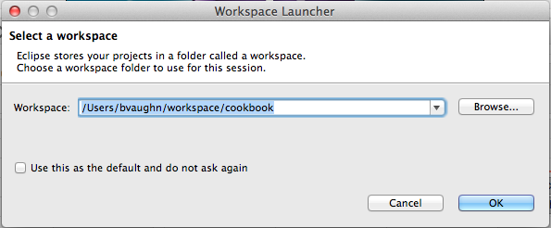

## Import CQ Cookbook Project

File -> Import

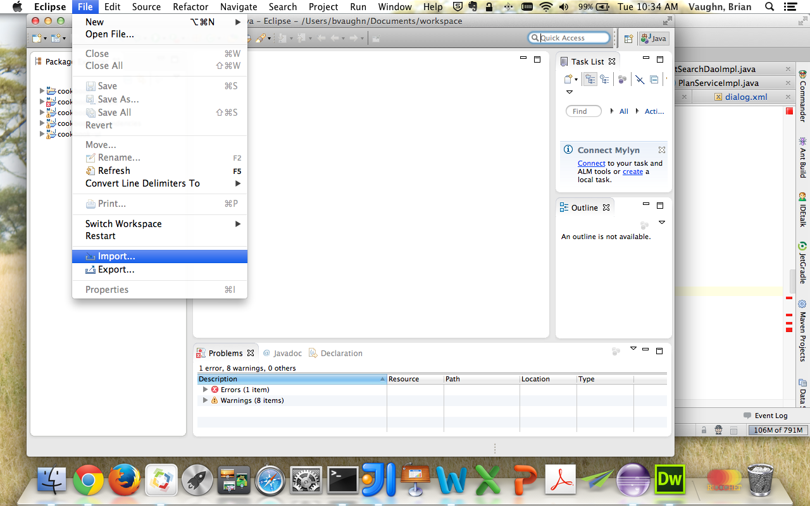

Maven -> Existing Maven Projects

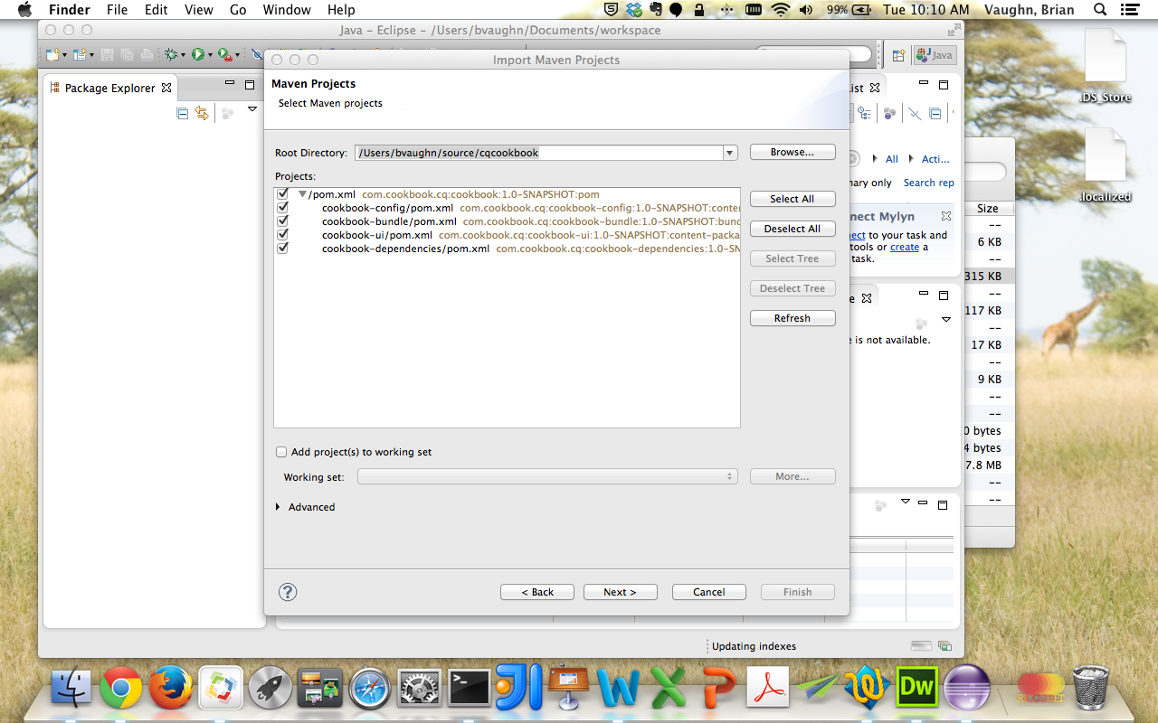

Change Root Directory: cqcookbook folder

Make sure all sub modules are checked.

Click Next then click Finish.

## Adobe AEM Installation

The CQ jar provided by adobe is an executable jar. To install the server you will need to create a folder structure similar to /Users/<yourname>/adobe/cq5_6 and create an author and publish folder. Copy your cq jar allow with the license into the publish and author folders. In the author folder rename the jar to cq56_author_P4502.jar and double click the jar. The installation will take a couple minutes. Inside the publish folder rename the jar to cq56_publish_4503.jar and double click to start the installation of the publisher instance.

Once complete, shutdown both servers so we can edit the start scripts. Under author and publish you will now have a crx-quickstart folder. Under author/crx-quickstart/bin edit the start scripts. Modify the following to include author and local run mode:

# runmode(s)

if [ -z "$CQ_RUNMODE" ]; then

CQ_RUNMODE='author,local'

Fi

Under publish/crx-quickstart/bin edit the start scripts. Modify the following to include publish port and publish and local run mode:

# TCP port used for stop and status scripts

if [ -z "$CQ_PORT" ]; then

CQ_PORT=4503

Fi

# runmode(s)

if [ -z "$CQ_RUNMODE" ]; then

CQ_RUNMODE='publish,local'

Fi

Now you can use the start and stop scripts to start your server.

## FileVault Installation

The FileVault application allows you to import recourses into your AEM instance from the command line.

Extract the zip file located inside the <AEM installation path>/crx-quickstart/opt/filevault folder

## Valutclipse plugin

Access the plugin via the Eclipse Marketplace:

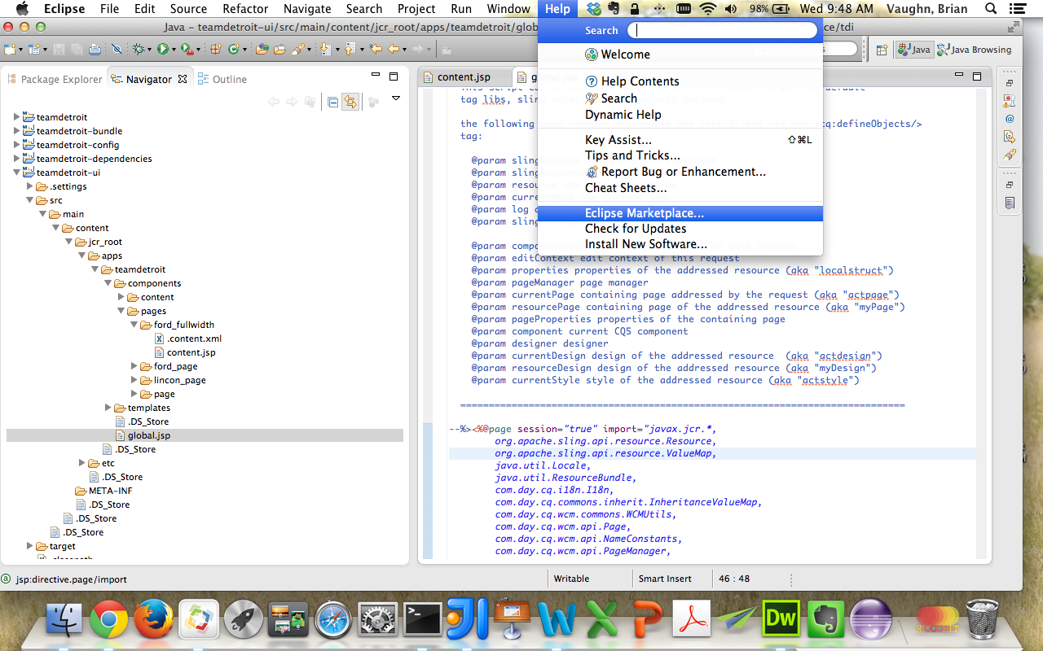

Search for ‘vaultclipse’ and install ValutClipse 0.2.4

Once installed, update Eclipse preferences for ValutClipse:

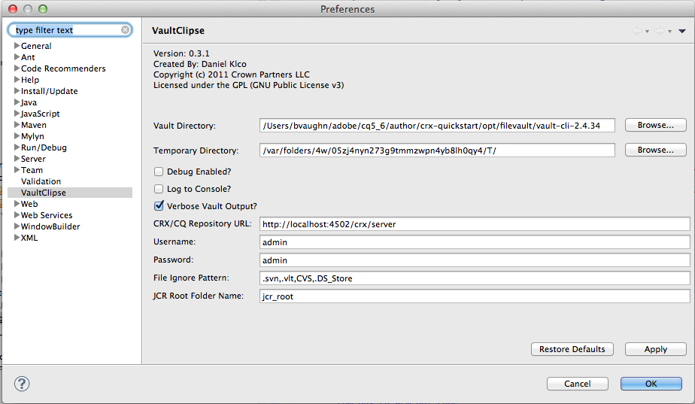

## Install web Development Tools

To ease JSP and XML editing, install the Eclipse Java Web Developer Web Tools and Eclipse Web Developer Tools.

Inside Eclipse, click Help -> Install New Software…

Choose work with All Available Sites and then after the look for Web, XML, Java EE and OSGi Enterprise Development. Under that structure you should find the web developer tools to install.

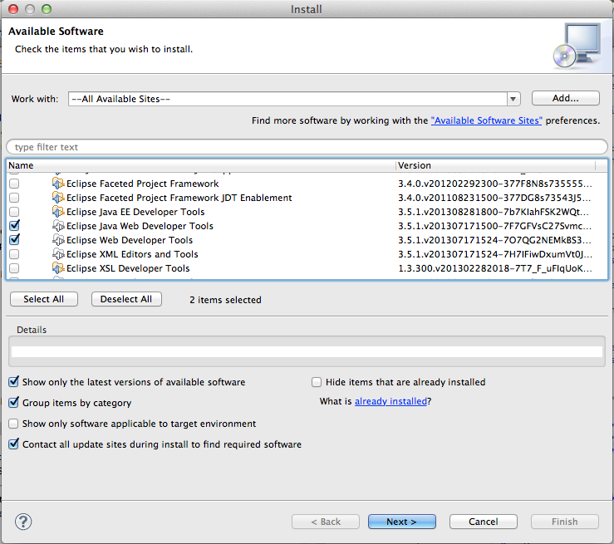

## Multiple Workspaces – Max OSX only

By default you can’t easily open multiple workspaces at once with Eclipse on the Mac. Install the below software to add the option to open a workspace.

<http://update.resheim.no/eclipse-utilities/>

Inside Eclipse, click Help -> Install New Software…

Click Add.. and enter the above url and follow the wizard to install the packages.